

|  |  |
| --- | --- |
| **Name** | **Abd-Elrahman Kamal El-Dien** |
| **ID** | **1091** |
| **Sec** | **20** |
| **Group** | **4** |
| **Github Link** | <https://github.com/abdelrahmank123/html-project-repository> |
| **Github Page** |  |

|  |
| --- |
| **Supervisors** |
| **Dr\ Ahmed Bayoumi** |
| **Dr\ Shady Elmashad** |
| **Dr\ Abdelhamid Attaby** |

**Artificial Intelligence**

**Subject brief:**

Artificial intelligence (AI) is [intelligence](https://en.wikipedia.org/wiki/Intelligence) demonstrated by [machines](https://en.wikipedia.org/wiki/Machine), unlike the natural intelligence [displayed by humans](https://en.wikipedia.org/wiki/Human_intelligence) and [animals](https://en.wikipedia.org/wiki/Animal_cognition), which involves consciousness and emotionality.

**About the Website in the project**



**The main Page:**

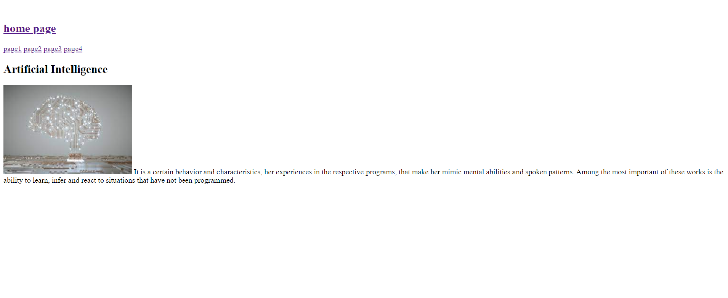

Main page codes:

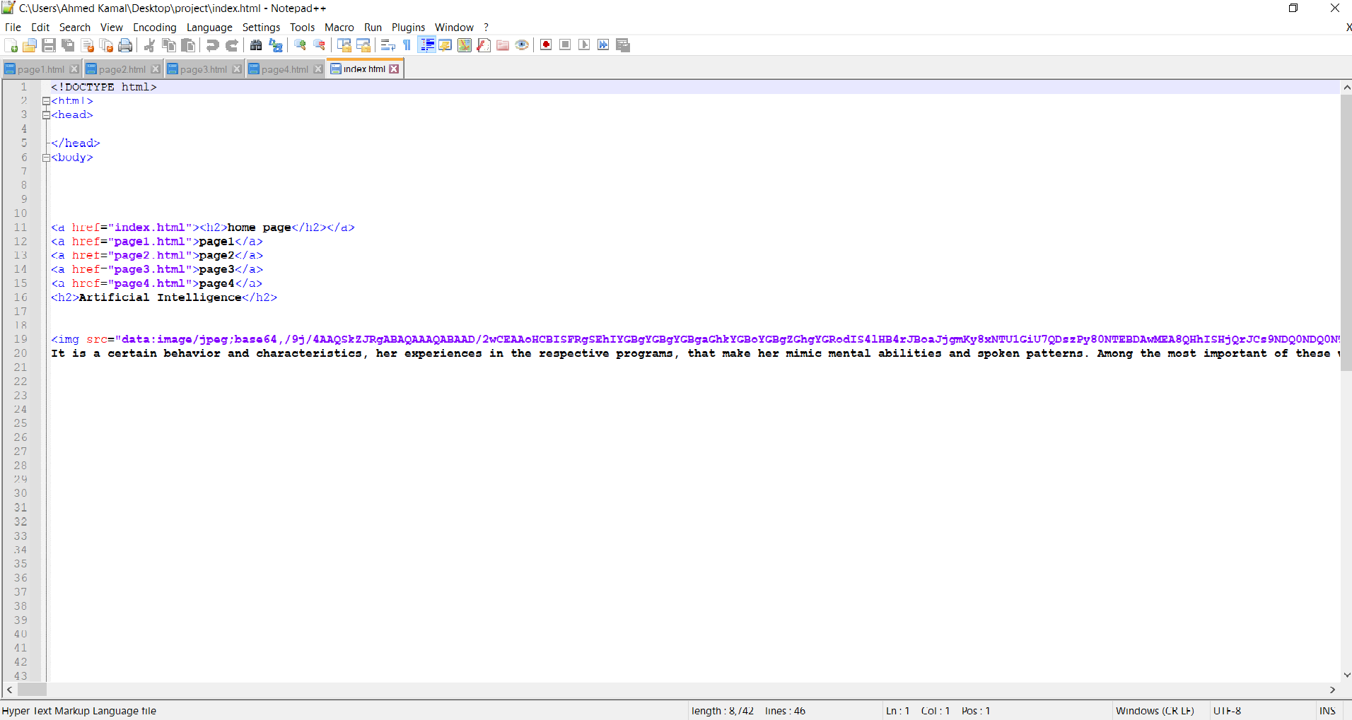

**Page1: types of artificial intelligence**

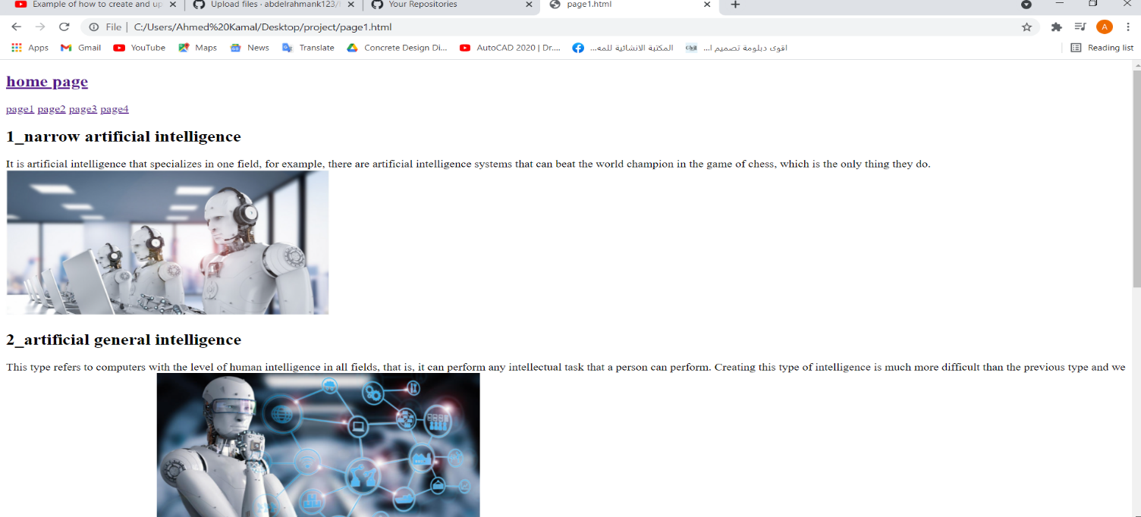

Page 1 codes:

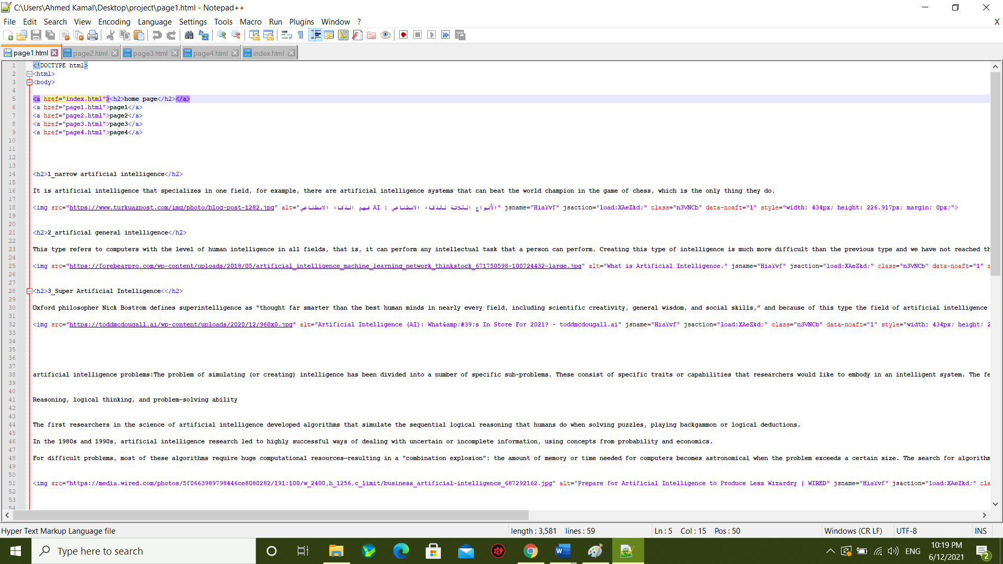

**Page2: Artificial intelligence in the corporate sky**

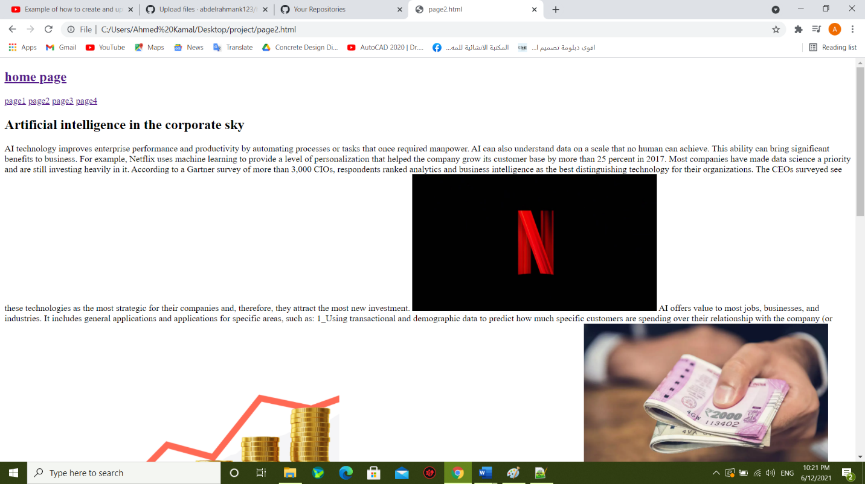

Page 2 codes:

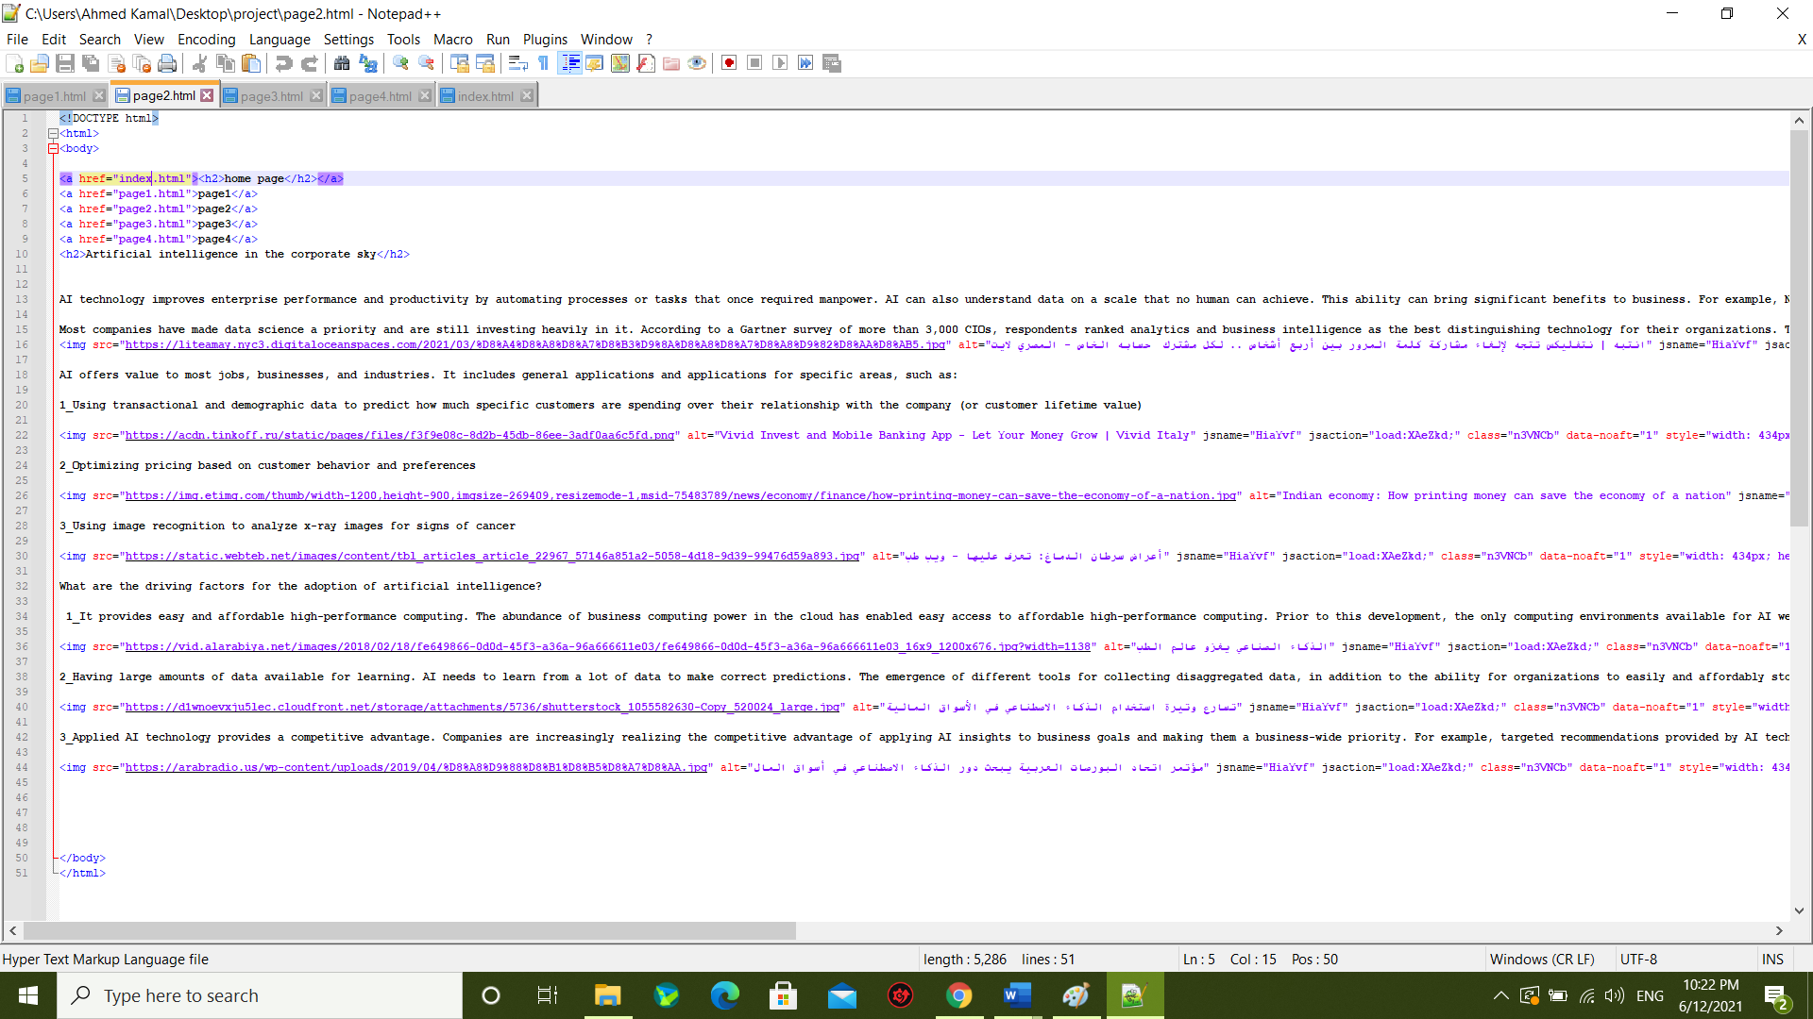

**Page 3: representation of knowledge**

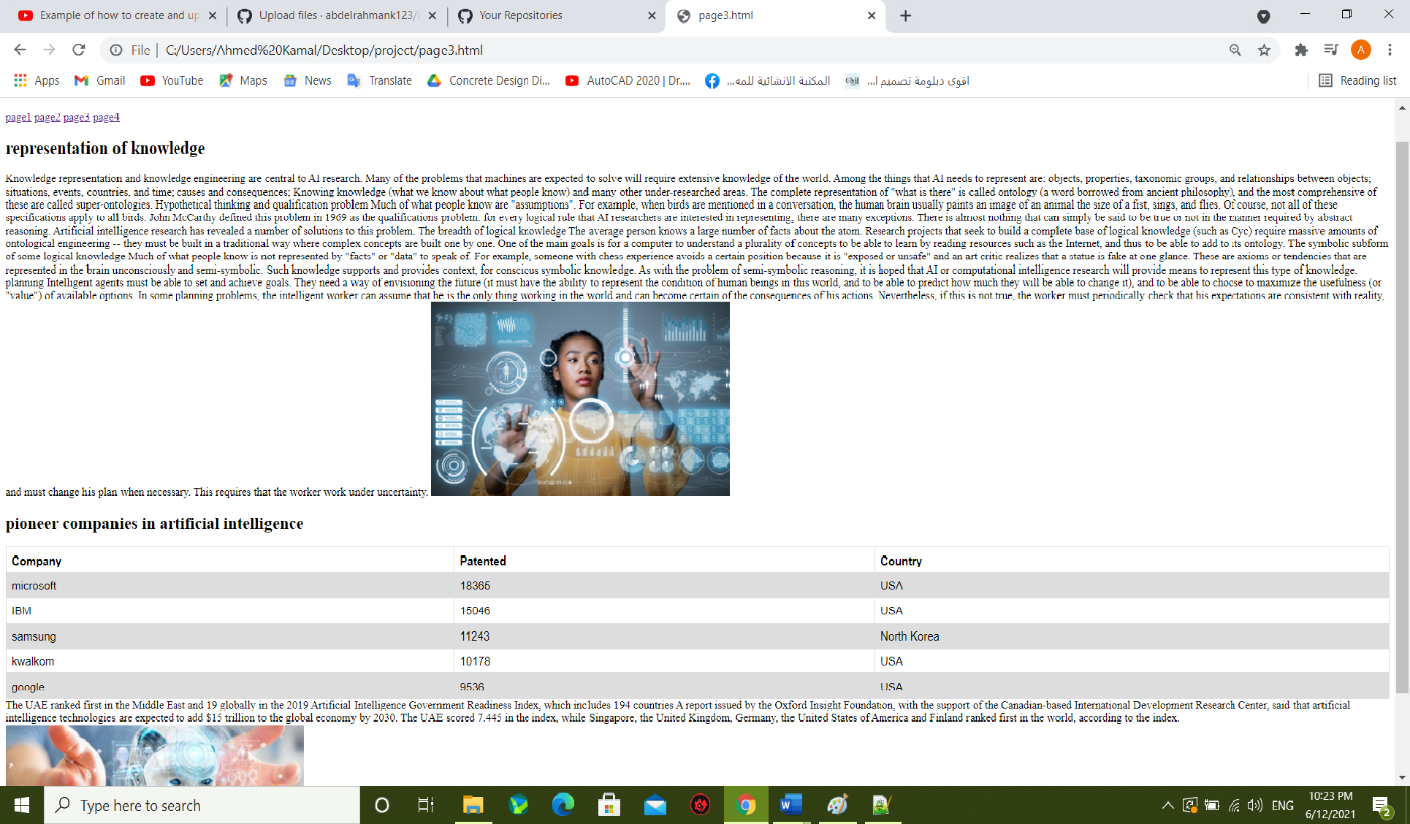

Page 3 codes:

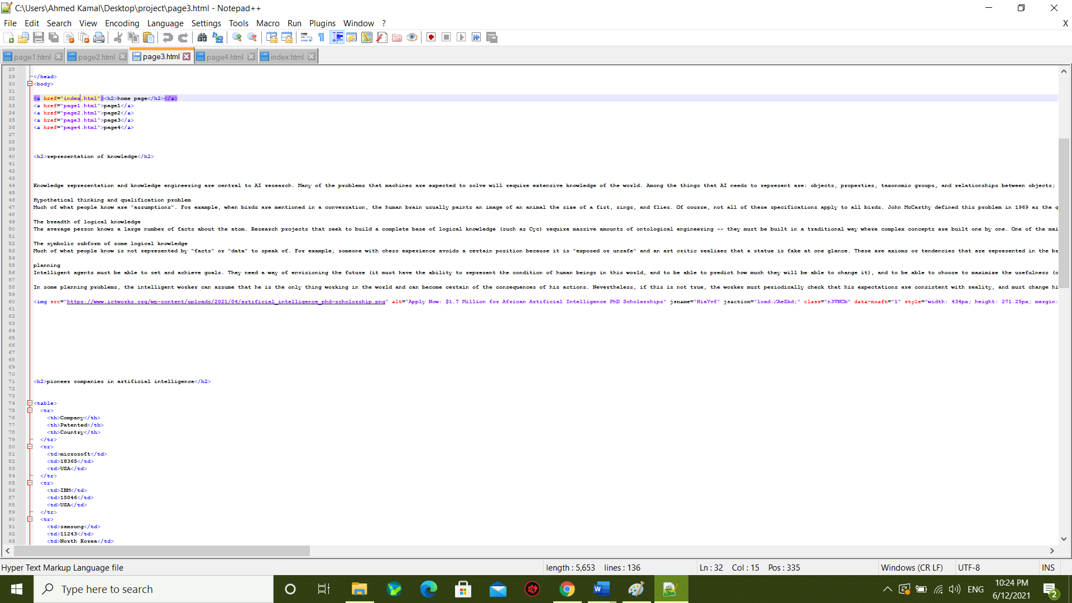

**Page 4: Benefits and challenges of activating artificial intelligence**

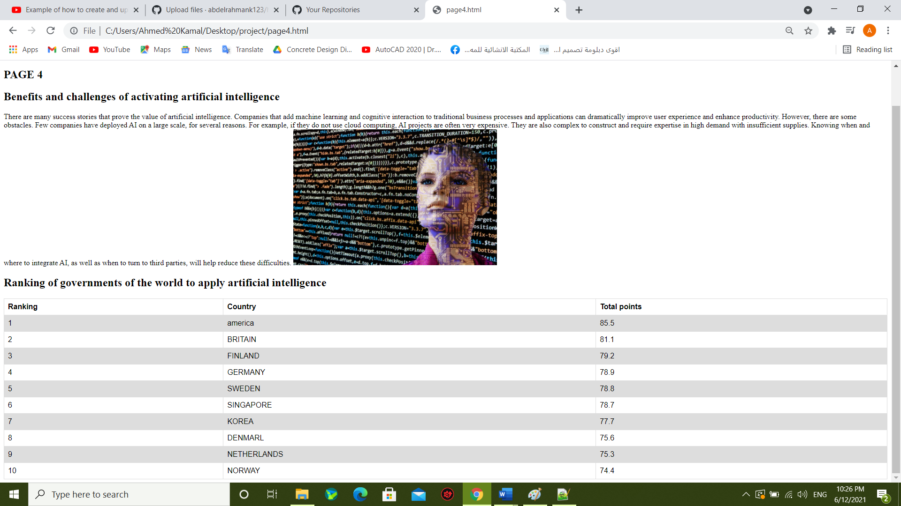

Page 4 codes:

